Most spectacular Rockies

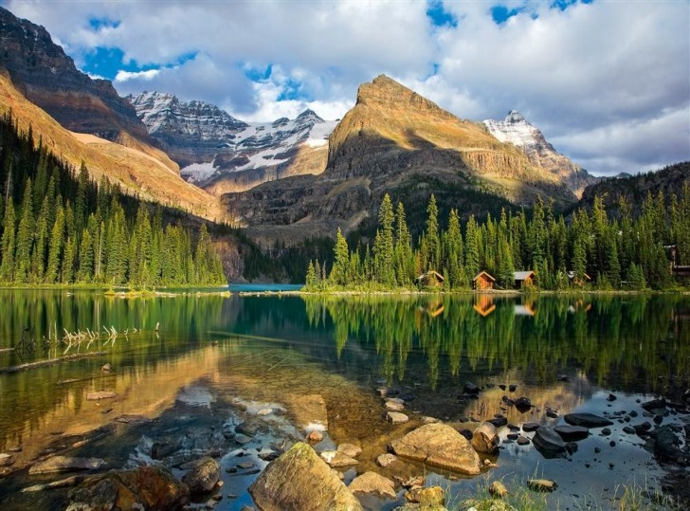
Canadian Rockies rise forming an impenetrable wall of rock and perpetual snow on the prairies of Alberta and the wide valley of the Rocky Mountain Trench. In the nineteenth century the search for the natural passes through the mountains took first hunters and railroad workers then, to discover a scene of widespread languages ​​glaciers, turquoise lakes and peaks of dark rock. Today these treasures are grouped into national parks Jasper, Banff and Yoho, declared in 1984 a World Heritage Site by Unesco.
The small town of Jasper is the beginning of the route, through the Icefields Parkway, Banff Park reached, 232 miles south. Jasper was named after Jasper Hawes, an employee of the North West Company fur company, whose cottage on Lake Brule was an aid station and exchange of furs for trappers and Indians Iroquois and stoneys between 1814 and 1817 , a century and a half later , Sidney Pollack Hawes was inspired to shoot the Jeremiah Johnson ( 1972 ) .
Jasper National Park boasts the largest tract of virgin land and wildlife of the country, plus a network of a thousand miles of trails through forests of fir and broad meadows On a map, its almost 11,000 km2 are a great spot with a couple of road near Jasper . One traces the Maligne River, which meanders its way between limestone walls 55 meters high in places.
The pathway runs through the canyon incredibly narrow passages into Lake Maligne. It is the largest of the Rockies and receives water from several glacier tongues seen during the ride in the boats that sail to the Island Spirit. At night, from the camps of the shore, you hear the sound of avalanches sliding down the slopes of Monk Head and howls of coyotes.

Questions

1. - Canadia Rocks forming rise?

2. - What are your walls prairie rock and snow?

3. - What scenarios were discovered in the nineteenth century?

4. - What national parks arupan these treasures?

5. - What do you hear at night from shore camps?

